

Schematic used with Alere GPH CORDIVA System

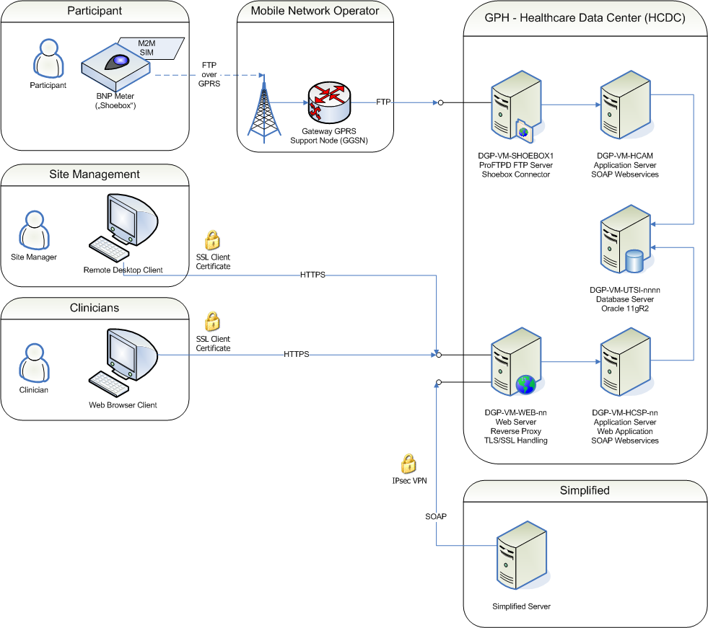

# HeartCheck Meter:

The HeartCheck meter is made by Alere Technologies, Ltd, Stirling Scotland.

The HeartCheck meter will be used to gather the following data and send this data to the Alere Connect Server:

1. Daily Weights
2. Daily Symptoms (yes/No)
   1. Are you coughing more today?
   2. Are you more short of breath today?
   3. Do you have more swelling today?
   4. Did you use extra pillows last night?
   5. Are you feeling dizzy today?
3. BNP test values (every other day or according to missing data schema)

The HeartCheck meter does not have a subject ID. It has a unique serial number which is cross-referenced in the Simplified CRF to a Subject ID. If a meter fails, it will be replaced with another meter with a unique serial number.

The HeartCheck meter will flag tests that fail with error codes.

The HeartCheck meter will flag results using the electronic test strip

These data must be filtered. Error events should be displayed graphically with BNP results but removed from the data that the BNP alerts will be applied to.

# BNP Alerts

Alere San Diego will provide an “Alert Module” that will be applied to the BNP and weights data.

a series of interventional alerts for fBNP will be used to identify when physicians and staff should consider treatment changes. For example:

1. Elevated fBNP values above certain thresholds will cause an alert to be generated. One example might be a threshold of 500 pg/mL. This threshold may also be set as a **patient specific value**, as knowledge is gained on the lowest maintainable levels for a given individual. The patient specific threshold may be lower or higher that 500 pg/mL depending on a more aggressive therapy, or cases where more aggressive therapy is contra-indicated. *Should we consider a lower BNP alert for some enrollment categories of patients such as HFPEF with BMI > 35? ...... < 500 pg/mL?*
2. A detectable and significant rise of fBNP(t), when BNP is over a certain minimal threshold will trigger an alert. One possible set of examples is when a multiplicative factor of 1.7x fBNP(t-τ) when fBNP(t-τ) is above 100 pg/mL will trigger an alert for any of the following time delays (τ in days):
   1. A rise over 7 days.
   2. A rise over 14 days.
   3. A rise over 28 days.

Weight and symptoms alerts

1. Weight fluctuations in excess of +/- 15% between sequential measurements (aberrant weight data) will also be flagged. The staff will be asked to contact the patient or care-giver and troubleshoot the weighing process.

Other Alerts

1. No HealthCOM data received for 4 or more days (excluding hospitalizations and scheduled holidays

Email alert notification to medical staff.

Can the email contain graphics illustrating the status of the patient?

In order to guard against “alert fatigue”, when one or more of the BNP alerts is generated, the alert notification system will **wait 7-14 days before another alert notification is made**, even though alerts may be generated during one or more of those days. However, daily alert status will be displayed in the HealthCOM system and is easily viewed. This gives the medical personnel a chance to respond to the alert and if indicated, make a change in therapy before additional alert notifications are made. The ability to turn off or modify the elevated BNP alert will also be available when further uptitration of medications is contra-indicated.

In addition to interventional alerts, the HealthCOM system may display or send **30-day reminders to the physicians or staff**. The purpose of the 30-day reminders is to advise the staff if therapeutic targets have been met, or what progress has been obtained in meeting the targets. For example, the notification may indicate that a predetermined BNP target such as a 2-fold reduction, or a patient-specific target, has not been reached yet. The 30-day reminder may also indicate that the target has been reached and maintained over the current interval.

Any fBNP alert notification will require some action on the part of the investigators and medical staff. Each alert notification must be evaluated and a decision must be rendered as to whether an adjustment in therapy is warranted. The response to each alert notification must be documented even in cases where no changes in therapy are indicated. Response to all alert notifications will be monitored by the Compliance Committee.

Option: Information on closing out alerts and changes in medications and medication changes are entered in the Simplified CRF or in HealthCOM.

Date of alert: (00 XXX 0000)

Alert identifier

The action taken (choose all):

* Request an emergency or urgent or acute care visit
* Request a non-emergency visit
  + Clinic, or outpatient office visit
  + Home visit
* Contact or consultation by phone, email or other means
* No actions were taken
  + Therapy changes are contra-indicated
  + Other (specify)

Can the physician/staff choose which drugs to display?

Name of Medication:

Class of drug

Route of administration **(Pull Down)** (oral, IV, IM, IN, Other specify)

* Taking at study enrollment
* Taking at study completion or withdrawal

|  |  |  |
| --- | --- | --- |
| **[+]** | Start Stop Dose Units (PULL DOWN) Frequency (PULL DOWN)  Date: Date:  (00 XXX 0000) (00 XXX 0000) _______ _______ _______  *Can these fields be sorted chronologically if they are entered out of order?* | |
|  | Change in medication can best be characterized as (Choose one):   * New medication in class * Up-titration – disease progression * Up-titration – prophylaxis * Up-titration – to reach target therapeutic dose * Down titration - drug intolerance * Down titration - prophylaxis * Discontinuation * Medication action plan * Other | Medication changes were a result of (check all):   * HealthCOM BNP * HealthCOM Weight * HealthCOM Signs and Symptoms * Examination of patient * Remote consultation with patient * Other (specify): ______________ |

*One critical aspect to medications is that the information provided will only be updated when a change in medications is performed. Thus there needs to be a way of determining if the data is up to date or not when quickly viewed in the portal. To be discussed.*

# CRF data entry

Medical staff will enter subject’s data and clinical outcomes into the CRF. Some of the CRF data is sent to the HealthCOM server. (On-demand?)

Option: Information on medications and medication changes are entered in HeathCOM2 or in the Simplified CRF

# Request for reports

Different groups will require access to the HealthCOM portal with different levels of access and permissions

1. Alere San Diego Data Management and Biostats group: Full access to all HealthCOM screens for all sites and all arms of the study and the entire database including the ability to download the database for interim analysis
2. Alere San Diego and Alere Technologies Limited Clinical Operations group and Clinical Scientists: Full access to all HealthCOM screens for all sites and all arms of the study
3. Each hospital or study site: Access to only the single site’s information, restricted by study arm
4. Compliance Committee (Key investigators in the study, maybe independent cardiologists): Access to data that will allow determination of adherence to protocol via the responses to actionalble alerts. This should be very restricted amounts of data.

# Simplified CRF

Baseline data, demographics and medical history data from CRF:

Site ID 0000

Subject ID 000

Meter ID (may be more than one meter over time, but only one meter at a time) (Subject ID-Meter ID links Simplified CRF data and HeartCheck meter data)

Randomization arm (determines what data is visible to healthcare personnel and compliance committee) HABIT-II is not randomized. HABIT-III will be randomized.

Age

Sex (M/F)

Height (cm or inches)

Weight (Kg or Lbs)

Blood Pressure (sp/dp)

%LVEF

AFIB

Other arrhythmia or tachycardia

Angina

CAD

COPD

CRT

Diabetes

Hyperlipidemia

Hypertension

Prior MI

Alcohol or drug abuse

Data on hospitalizations and other clinical events (TBD)

Option: Information on closing out alerts and changes in medications and medication changes are entered in the Simplified CRF or in HealthCOM.

# Reports

**Dashboard Summary**

Modeled after current HeathCOM dashboard. Summary of all active subjects at each site.

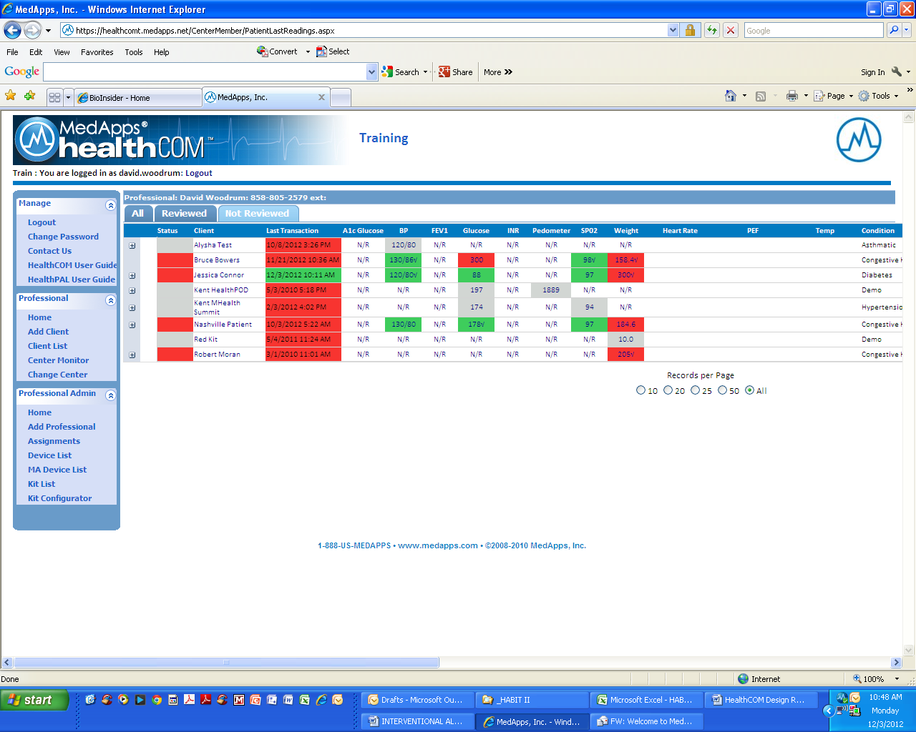

Client (Subject ID) (Subject ID matched to meter ID using CRF data.)

Date of last transaction (local time), BNP, Weight, answers to 5 symptom questions, Alerts summary (Y/N), Red, Green color coding of information based on alerts generated. (HealthCOM data and Alerts algorithms data)

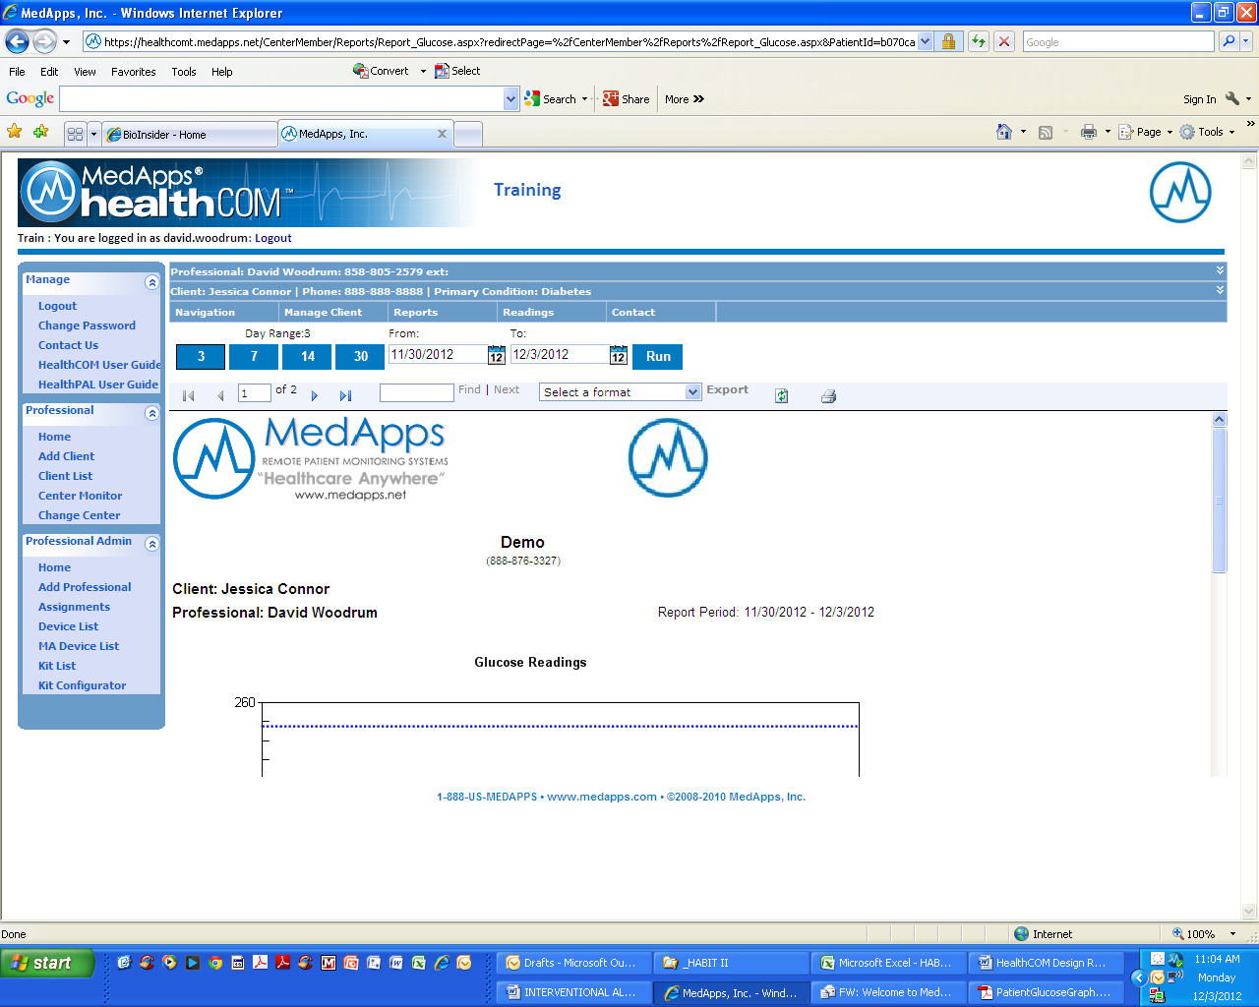

**Date range of report:** 7, 14, 30, 60, 90, 120, 150, 180 days

(Adjusts tables and graphs accordingly)

**Report Header** containing demographics and medical histories (see details below)

**Subject Report Mock-up**

*These could be yes/no or only appear in header when yes.*

**http://myimi/PublishingImages/alerelogo.jpg**

|  |  |  |  |
| --- | --- | --- | --- |
| Site ID 0000 | Subject ID 000 | Meter ID | Randomization arm |
| Age | Sex (M/F) | Height (cm or inches) | Weight (Kg or Lbs) |
| %LVEF | AFIB | Blood Pressure (sp/dp) | Diabetes |
| Angina | CAD | COPD | CRT |
| Hyperlipidemia | Hypertension | Prior MI | Alcohol or drug abuse |
| Other arrhythmia or tachycardia | |  |  |

*(Subject ID-Meter ID links Simplified CRF data and HeartCheck meter data) (Determines what data is visible to healthcare personnel and compliance committee) (May be more than one meter over time, but only one meter at a time)*

**HF Hospitalization**

Failed BNP Test

**BNP Alert**

**Symptoms**

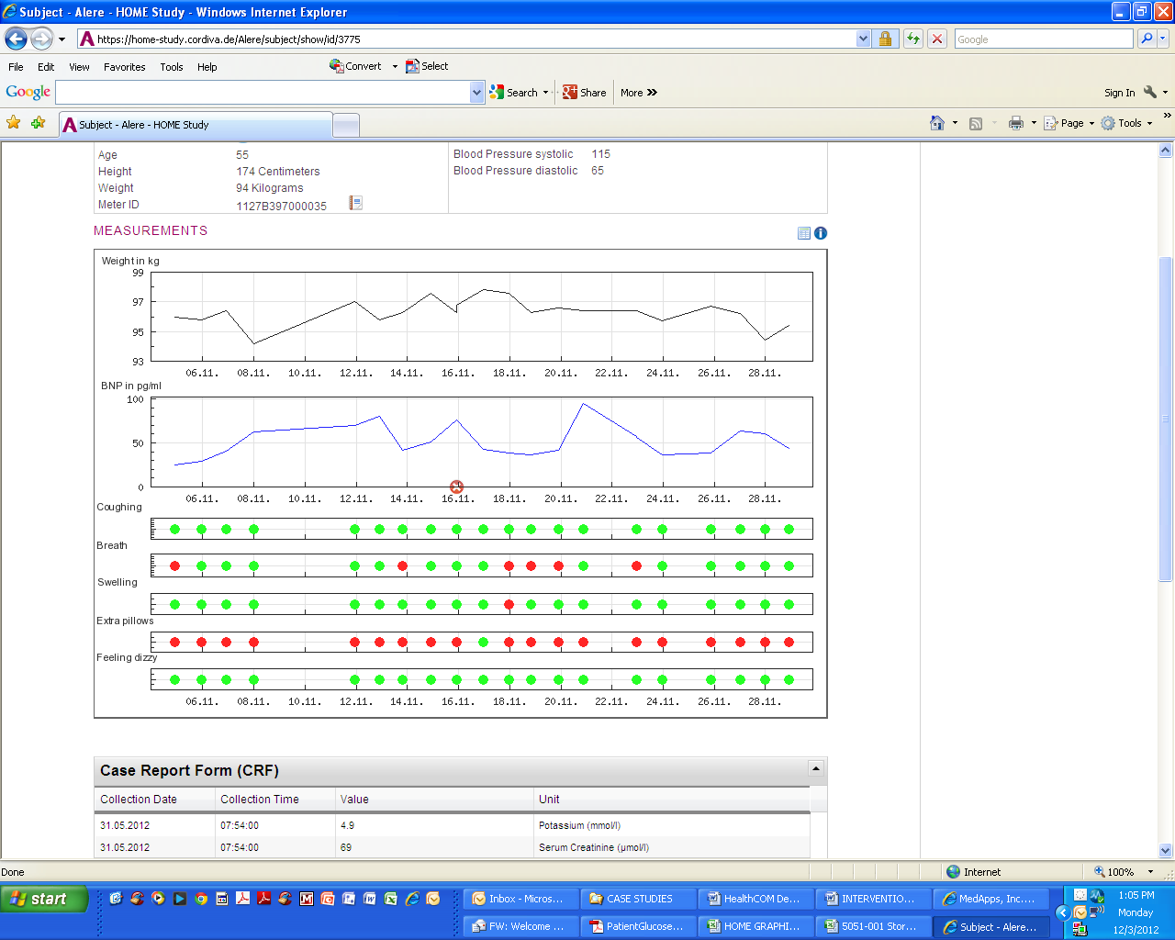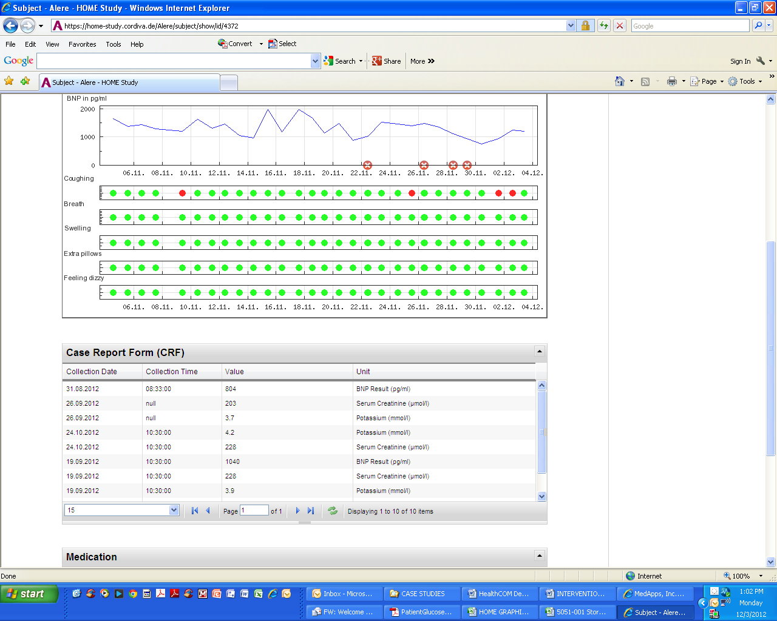

*(Stack the key drug graphs)*

|  |  |  |  |
| --- | --- | --- | --- |
| **BNP** | | | |
| **Date/time (local)** | **Date/time (GMT)** | **BNP Value (pg/mL)** | **Alert #** |
|  |  |  |  |
|  |  |  |  |
|  |  |  |  |
|  |  |  |  |
|  |  |  |  |
|  |  |  |  |
|  |  |  |  |
|  |  |  |  |
|  |  |  |  |

|  |  |  |  |
| --- | --- | --- | --- |
| **Weight** | | | |
| **Date/time (local)** | **Date/time (GMT)** | **Weight (kg/lbs)** | **Alert #** |
|  |  |  |  |
|  |  |  |  |
|  |  |  |  |
|  |  |  |  |
|  |  |  |  |
|  |  |  |  |
|  |  |  |  |
|  |  |  |  |

*(This table could still use a little work):*

|  |  |  |  |  |  |
| --- | --- | --- | --- | --- | --- |
| **Study Events** | | | | | |
| **Date/time (local)** | **Date/time (GMT)** | **Clinical Decompensation** | **HF Hosp**  **Admit** | **HF Hosp Discharge** | **HF Death** |
|  |  |  |  |  |  |
|  |  |  |  |  |  |
|  |  |  |  |  |  |
|  |  |  |  |  |  |
|  |  |  |  |  |  |
|  |  |  |  |  |  |
|  |  |  |  |  |  |
|  |  |  |  |  |  |
|  |  |  |  |  |  |

*(For medications we should be able to sort by drug name and date, or have separate tables for each drug listing).*

|  |  |  |  |  |  |  |  |  |  |
| --- | --- | --- | --- | --- | --- | --- | --- | --- | --- |
| **Medications** | | | | | | | | | |
| **Drug Name** | **Drug Class** | **Start Date** | **Stop Date** | **Dose** | **Units** | **Frequency** | **Route** | **Reason for change** | **Change based on** |
|  |  |  |  |  |  |  |  |  |  |
|  |  |  |  |  |  |  |  |  |  |
|  |  |  |  |  |  |  |  |  |  |
|  |  |  |  |  |  |  |  |  |  |
|  |  |  |  |  |  |  |  |  |  |
|  |  |  |  |  |  |  |  |  |  |
|  |  |  |  |  |  |  |  |  |  |
|  |  |  |  |  |  |  |  |  |  |
|  |  |  |  |  |  |  |  |  |  |

|  |  |  |  |
| --- | --- | --- | --- |
| **Lab Tests: Creatinine** | | | |
| **Date/time (local)** | **Date/time (GMT)** | **Value** | **Units** |
|  |  |  |  |
|  |  |  |  |
|  |  |  |  |
|  |  |  |  |
|  |  |  |  |
|  |  |  |  |
|  |  |  |  |
|  |  |  |  |
|  |  |  |  |

|  |  |  |  |
| --- | --- | --- | --- |
| **Lab Tests: Potassium** | | | |
| **Date/time (local)** | **Date/time (GMT)** | **Value** | **Units** |
|  |  |  |  |
|  |  |  |  |
|  |  |  |  |
|  |  |  |  |
|  |  |  |  |
|  |  |  |  |
|  |  |  |  |
|  |  |  |  |
|  |  |  |  |

|  |  |  |  |
| --- | --- | --- | --- |
| **Lab Tests: BNP** | | | |
| **Date/time (local)** | **Date/time (GMT)** | **Value** | **Units** |
|  |  |  |  |
|  |  |  |  |
|  |  |  |  |
|  |  |  |  |
|  |  |  |  |
|  |  |  |  |
|  |  |  |  |
|  |  |  |  |
|  |  |  |  |